# PROJECT PROPOSAL

**Human Resource Management system for Gemadept**

1. **SOLUTION DIRECTION**

## PROBLEM DOMAIN

The problem domain of this project is **Human Resource** and **Online Management**.

It involves developing a comprehensive and user-friendly HRM application that enables effective HR management for Gemadept. Key features of theproject include:

* **Employee Information Management**: Centralized database for storing and managing employee data, such as personal details, employment history, and contact information.
* **Recruitment and Applicant Tracking**: Tracking of applied applications and managing the recruitment pipeline.
* **Onboarding and Offboarding**: Structured procedures for integrating new hires into the organization and managing the exit process for departing employees.
* **Payroll Management**: Adjustable automated calculation of employee salaries, deductions, and taxes.
* **Time and Attendance Tracking**: Tools for monitoring employee attendance, tracking work hours, and managing leave requests.
* **Reporting and Analytics**: Generation of customizable reports and dashboards to provide insights into employee’s information and status.
* **Performance Management**: System for setting performance goals, conducting evaluations, and providing feedback to employees.
* **Learning and Development**: Scheduling training sessions and tracking employee progress in skill development.
* **Integration with Existing Systems**: Integration with other business systems such as ERP and accounting software.n.

In addition to the core functionalities, this development also focuses on:

* User-friendly interface for easy navigation.
* Customizable user roles and permissions.
* Automated workflows for HR processes.
* Mobile accessibility for remote workforce management.

## SOLUTION DOMAIN

* + 1. **The Discussion of Alternative Solutions**

The HRM solution entails expertise in HR management, employee information systems, recruitment, applicant tracking, onboarding, offboarding processes, payroll management, reporting, analytics, integration with existing systems, etc. It also encompasses application programming, user interface design, and hosting servers.

The medium in which this solution can be implemented are plenty, from website, OS app, to mobile. However, we have chosen to develop a web-based application due to its adaptability and accessibility. Other options were ruled out due to their limitations in meeting the comprehensive requirements of Gemadept's HRM needs, the reason for why the alternatives were discarded is as follow:

|  |  |
| --- | --- |
| **Alternative** | **Discard reasons** |
| Desktop-based application | ✗ It can take up unnecessary storage space on the user’s device.  ✗ Limiting accessibility for users who require remote access or use multiple devices.  ✗ Maintenance of different version base on their OS can be tedious.  ✗ User needs to manually install updates. |
| Mobile application | ✗ Elevated time and resources required to develop compatible versions for each mobile platform.  ✗ Restricted availability on mobile platforms such as iOS and Android.  ✗ Incompatibility or insufficient hardware capabilities of mobile devices may hinder the execution of the application's various tasks..  ✗ Elaborate approval procedures for mobile applications on App Store and Google Play, potentially causing project delays incapable of handling the app’s various processes. |

Web-based applications, provide greater accessibility, cross-platform compatibility, and ease of updates, which made it the best solution out of all the option*s*, for example, the user can access this app anywhere and does not need specific devices to be able to use this app.

The main platform where this application will be hosted is a hybrid of dedicated servers on AWS instances. This solution will guarantee the ease of customization and reliability of dedicated servers, while also incorporating the flexibility and scalability of the AWS cloud.

|  |  |  |  |
| --- | --- | --- | --- |
| **Criteria** | **AWS and Dedicated hybrid** | **Dedicated server** | **On-premises** |
| Scalability | Auto-scaling services facilitate handling increased traffic efficiently. | Limited scalability; manual action and downtime involved in scaling. | Limited scalability; additional hardware and resources required for scaling. |
| Reliability | Multiple availability zones and redundancy features minimize downtime. | Reliability dependent on hardware and network maintenance. | Reliability dependent on infrastructure maintenance. |
| Infrastructure | Reduced latency with data centers in various regions, enhancing proximity to customers. | Limited by physical server location; latency reduction requires servers in different regions. | Restricted by physical infrastructure location; latency reduction requires additional premises environments. |
| Security | The web will be protected by Laravel’s various security modules, and AWS can provide the added security of ACLs and security group. | Security dependent on settings implemented on the dedicated server, which may require significant time and effort for maintenance and modifications. | Security dependent on infrastructure, necessitating more resources for comprehensive protection. |

|  |  |  |  |
| --- | --- | --- | --- |
| Cost | Pay-as-you-go model enables scaling resources as needed, cost-efficient for varying business sizes. | Costly hardware maintenance, less cost-effective for small businesses. | Costly setup, maintenance, and resources required. |
| Integration with other tools | Seamless integration with all Amazon services, and other framework that can help to integrate with Gemadept current technologies. | Limited integration, manual setup required. | Limited integration, manual setup required. |

## The KoST Analysis of My Knowledge

* **Knowledge *(what you know)***

Required knowledge:

* **Web-based application**: Knowledge of HTML/CSS, PHP, Javascript and frameworks like Laravel and React.
* **Cloud services**: Knowledge of AWS platform.
* **Hosting server**: Expertise in server management, networking, databases, and understanding of hosting services.
* **Human Resource Management**: Knowledge of cooperate human resource management, and management processes.

My knowledge:

* **Web Development Courses**: Enrolled in two web development courses and acquired foundational knowledge of HTML, CSS, PHP, and JavaScript.
* **Database Management System Course**: Enrolled in a Database Management System course and gained a basic understanding.
* **AWS Cloud Architecture Course**: Completed an AWS cloud architecture course and acquired a foundational understanding of its services.
* **HR Management Basics**: Possess basic knowledge of HR management through engagement in volunteer operations involving personnel allocation and administration.
* **Skills *(your experience)***

Required skills

Technical Skills:

* **Framework/Tools Proficiency**: Practically experienced in utilizing chosen frameworks/tools to facilitate smooth platform development.
* **Application Development and UI Design**: Proficient in application development projects and user interface design.
* **Server Management and Deployment**: Skilled in inspecting hosting servers and deploying platforms into Production environments.
* **Infrastructure Acquisition**: Knowledgeable in hiring or acquiring necessary infrastructure/resources.

Domain knowledge:

* **HRM Applications**: Experienced with HRM applications and their connections.
* **Human Resource Operations**: Understanding the core operations of human resources.
* **Third-Party Integration**: Proficient in third-party integration to ensure compliance with security regulations.

My skills

Technical Skills:

* **Web Development**: Built three small web projects using HTML/CSS, Javascript, and PHP.
* **Database Management**: Proficient in creating and managing databases using SQL Developer by Oracle.
* **UI/UX Design**: Skilled in web user interface design utilizing Figma and Adobe XD.
* **Cloud Hosting**: Experienced in hosting websites on the AWS cloud.

Domain knowledge

* + **Employee Data Auditing**: Experienced in auditing employee data and observing recruitment pipelines.
  + **HRM System Feature**: Familiar with using features within a larger Human Resource Management (HRM) system.
* **Technology *(existing solution)***

Web-based HRM systems can be built using a variety of current technologies and solutions. Among the essential tools and technologies are:

* **Proprietary HRM Software**: Companies like SAP (SuccessFactors), Oracle (Oracle HCM Cloud), and Workday offer comprehensive HRM suites that cover a wide range of HR functions. These solutions often provide modules for core HR, talent management, workforce planning, payroll, benefits administration, and analytics.
* **Cloud-based HRM Platforms**: Cloud-based HRM platforms like BambooHR, Namely, Zenefits, and Gusto offer scalable and customizable solutions for managing HR processes. These platforms typically provide features such as employee self-service portals, onboarding/offboarding tools, performance management, time and attendance tracking, and compliance management.
* **Open-source HRM Solutions**: Open-source HRM solutions provide flexibility and customization options for building web-based HRM applications. Popular open-source HRM frameworks and platforms include OrangeHRM, Sentrifugo, IceHrm, and Odoo HR. These solutions offer modules for managing employee information, leave management, attendance tracking, and more.

## Rationale

Following a comparative examination of several options and a gap analysis utilizing the KsoT framework, the following factors indicate that developing a web application and hosting it on AWS cloud services is the best course of action for this project:

* Web-based applications offer a user-friendly interface and are easily accessible from various devices, allowing them to seamlessly integrate and blend in with the current system.
* Scalability capabilities provided by AWS enable the platform to accommodate growing traffic and customer needs. By growing resources as needed, the pay-as-you-go model also guarantees cost-effectiveness.
* AWS provides features like Application Load Balancing, EC2 hosting, and comprehensive security options that are essential for running an e-commerce platform.
* I have the necessary abilities to construct a modest project like this one.

## Final Solution

* The HRM Application will be built as a **web-based application** using **React** for front-end, and **Laravel** for the back-end.
* The HRM Application will be built on **Nginx Web Servers** accompanied by **Cloudflare** and hosted on an **EC2** instance, this combination offers a powerful solution for web application development, providing benefits in terms of performance, security, scalability, and reliability.
* **Oracle Database** will be used to store user data because it can handle a large volume of data efficiently, moreover, Oracle security and compliance are top-notch which can help with protecting user’s sensitive data.

# ARCHITECTURE DESIGN

## 3-TIER ARCHITECTURE DESIGN

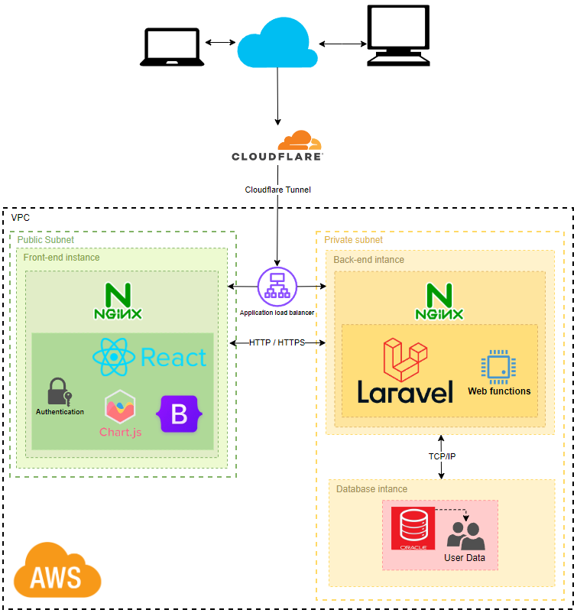



*Figure 1: A 3-tier AWS architecture design of the HRM Application*

**TIER 1: PRESENTATION**

The front end interface of the application will be in charge for housing the UI of the application, it is composed of the following component:

* Cloudflare: For optimizing and securing the delivery of web applications.
* React: A JavaScript library for building user interfaces.
* Bootstrap: A front-end framework for developing responsive websites.

**TIER 2: APPLICATION**

This layer handles the business logic and core functionalities of the platform, such as displaying reports, processing calculations, and analyze the data it collects. Tier 2 connects the user interface (tier 1) and the database (tier 3).

The framework used for this layer is Laravel, and it has the following component:

* Laravel: A PHP web application framework for building web applications following the model-view-controller (MVC) architectural pattern.
* Oracle DB connection: Allows Laravel to connect and interact with an Oracle database.
* Business Logic Modules: Custom modules developed within the Laravel framework to handle specific business logic and functionalities of the application.
* API Integration: Components responsible for integrating with external APIs to fetch or send data as required by the application.
* Authentication and Authorization: Components responsible for managing user authentication and authorization within the application, ensuring secure access to resources based on user roles and permissions, this part will be the backbone for the authentication feature in the front end.

## TIER 3: DATABASE

Data administration, data query, and storage are handled by this layer. Databases and a database management system are part of Tier 3. It is in charge of guaranteeing the availability, security, and confidentiality of data. It enables the execution of insert, update, and delete queries. In order to deliver the data that the user or application layer request, this layer communicates with Tier 2.

Oracle Database is used for this layer, its components are:

* Data Models: Structures and relationships defined within the Oracle database to organize and store data efficiently.
* Data Access Layer: Components responsible for accessing and manipulating data stored in the Oracle database, including querying, inserting, updating, and deleting records.
* Database Security: Measures implemented within the Oracle database to ensure data confidentiality, integrity, and availability, including user access controls, encryption, and auditing.
* Database Administration Tools: Tools used for monitoring, managing, and optimizing the performance of the Oracle database, such as Oracle Enterprise Manager and SQL Develop.

## UML CLASS DIAGRAM

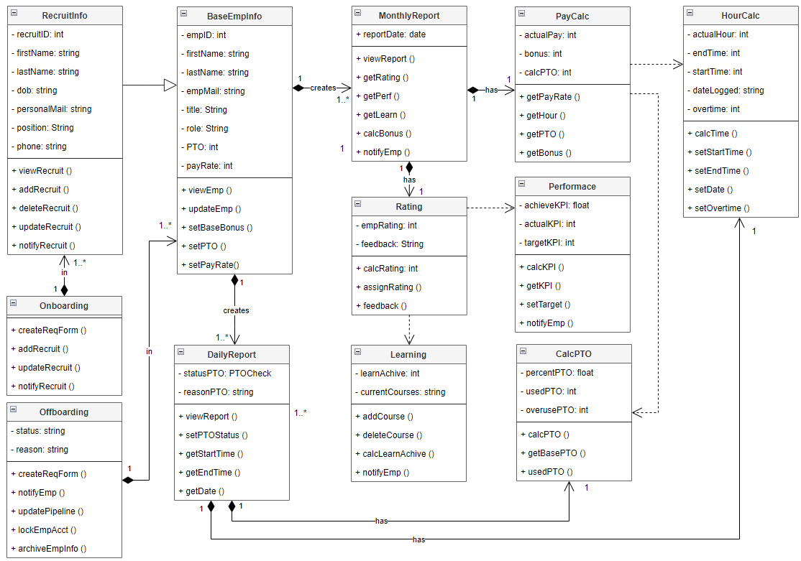



*Figure 2: App Class UML*